
EAST WINDSOR TOWNSHIP BUREAU OF FIRE PREVENTION 16 LANNING BLVD.
EAST WINDSOR, NJ 08520 609-443-4000 (ext. 406)
609-443-4000 (ext. 407)

CERTIFICATE APPLICATION FOR:

SMOKE DETECTORS, CARBON MONOXIDE DETECTORS & LABELLING: INDIVIDUALLY OWNED ONE & TWO FAMILY DWELLING, CONDOMINIUM & TOWNHOUSE

Date.: _ Scheduled Inspection:
(Scheduled Inspection Completed by Fire Prevention) Date of Settlement Closing: Owner Name: _ Inspection Address:
Block: Lot:

Mailing Address: (if different than above) Telephone (owner):

Contact Name: Contact Telephone:

Smoke detectors, carbon monoxide detectors & labelling shall be installed prior to inspection. See attached forms for instructions & placement locations of smoke detectors, carbon monoxide detectors & labelling.

INSPECTION FEE: $50.00 RE-INSPECTION FEE: $25.00
*Please make all checks payable to: East Windsor Township
Payment: Cash$ Check$ Check# Date:

By:

Signature of Owner/ Agent: Certificate to be: Picked up or Mailed
Email:


EAST WINDSOR TOWNSHIP BUREAU OF FIRE PREVENTION 16 LANNING BOULEVARD EAST WINDSOR, NJ 08520
609-443-4000 (EXT. 406)
609-443-4000 (EXT. 407)

IMPORTANT NOTICE - PLEASE READ
Inspection Date: between the hours of and (EXACT TIMES WILL NOT BE GIVEN)
ALL SMOKE AND CARBON MONOXIDE DETECTORS MUST BE UL LISTED AND LABELED.

SMOKE DETECTOR REQUIREMENTS:

- A minimum of one smoke detector per level of dwelling, including basement.
- In the basement, the smoke detector shall be located on the ceiling/beam at the bottom of the stairs.
- Smoke detectors shall be located no more than 10 feet from the bedroom door.
- If a loft/attic area is open and can be used as living space and there is a headspace of 7 feet or more, a detector will be required.
- A floor level is a level with three steps or more between levels.
- Existing hardwired detectors cannot be replaced with battery-only type detectors.
- All alarms must be listed, tested, and labeled.
- If an alarm/central station is in place, the following information will be required:
  - Alarm company name
  - Phone number
  - Code to place system in test
  - Code to set alarm

CARBON MONOXIDE REQUIREMENTS:

A carbon monoxide detector is required on each level where bedrooms are located and shall be no further than 10 feet from the bedroom door.

- Carbon Monoxide detectors must be in all dwellings, except those not containing fuel-burning appliances or that do not have an attached garage (an open parking structure is not an attached garage). Carbon Monoxide detectors may be battery-powered, plug-in type, or hard- wired and installed on a wall, ceiling, or in accordance to manufacture's installation instructions.

- Existing hard-wired detectors cannot be replaced with only battery-powered detectors.

Uniform Fire Code of New Jersey Certification Criteria One & Two Family Homes

Homes Built Prior to 1977 | Homes Built After 1977 | Newer Homes – 1990’s and newer
Smoke Alarms  - 10 Year Sealed Battery Type  - On each floor level  - Within 10’ of bedrooms | Smoke Alarms  - Hardwired Electric  - Interconnected  - On each floor level  - Within 10’ of bedrooms | Smoke Alarms  - Hardwired Electric  - Battery Backup  - Interconnected  - On each floor level  - In each bedroom
Carbon Monoxide Alarms  - Within 10’ of sleeping areas | Carbon Monoxide Alarms  - Within 10’ of sleeping areas | Carbon Monoxide Alarms  - Within 10’ of sleeping areas
Labelling  - All secondary power (generators, solar, battery backup/storage) on meter and panels. | Labelling  - All secondary power (generators, solar, battery backup/storage) on meter and panels. | Labelling  - All secondary power (generators, solar, battery backup/storage) on meter and panels.

SMOKE/CARBON MONOXIDE ALARMS
DINING
KITCHEN
BED
BED
LIVING

BEDROOM
SHOULD BE LOCATED IN BEDROOMS
BETWEEN THE SLEEPING AREA(S)
WITHIN THE’
VICINITY OF THE BEDROOMS THE FAMILY LIVING AND THE REST OF
AREA(S).

INSTALLATION
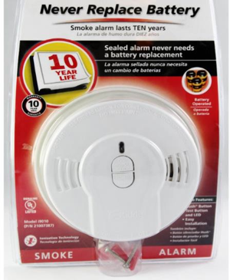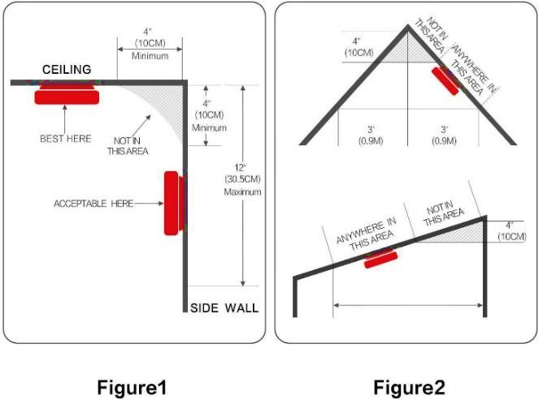

Smoke Detector, Carbon Monoxide & Labelling Fact Sheet

The New Jersey Uniform Fire Code 5:70-2.3(a) states: “Before any one or two-family structure is sold, leased, or otherwise made subject to a change of occupancy for residential purposes, the owner shall obtain a Certificate of Smoke Alarm, Carbon Monoxide Alarm Compliance (CSDCMAC), evidencing compliance with N.J.A.C 5:70-4.19, from the appropriate enforcing agency.”

Operable Smoke Detector on each level of the dwelling, including the basement depending on the year built.

Homes built post-1977 will be inspected for what the building code required at the time the house was built. If your home was renovated, all improvements to fire protection must be maintained as designed.

** If your electric-powered smoke detectors are over 10 years old, they must be replaced prior to inspection per manufacturer warranty requirements.

** All battery-powered-only smoke detectors must be changed to a 10-year sealed battery detector.

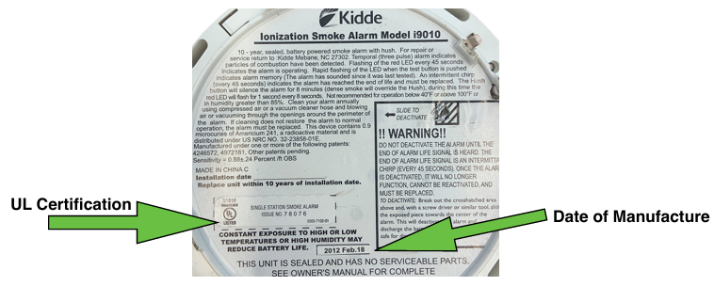

Where not to locate smoke detectors
To avoid false alarms and/or improper activations, avoid installing smoke detectors in the following areas:
• Kitchen - smoke from cooking may cause nuisance alarms.
• Bathroom - excessive steam from a shower may cause a nuisance alarm.
• Near forced air ducts used for heating or air conditioning. Air movement may prevent smoke from reaching the detector.
• Near a furnace of any type - air and dust movement and normal combustion products may cause a nuisance alarm.

Uniform Fire Code no longer requires fire extinguishers to be installed upon the sale of property or change of occupancy
** Please test your detectors prior to scheduling your inspection. **

